Curriculum Vitae

Full name: Le Thi Bich Hang

Email: hangltb@ntu.edu.vn
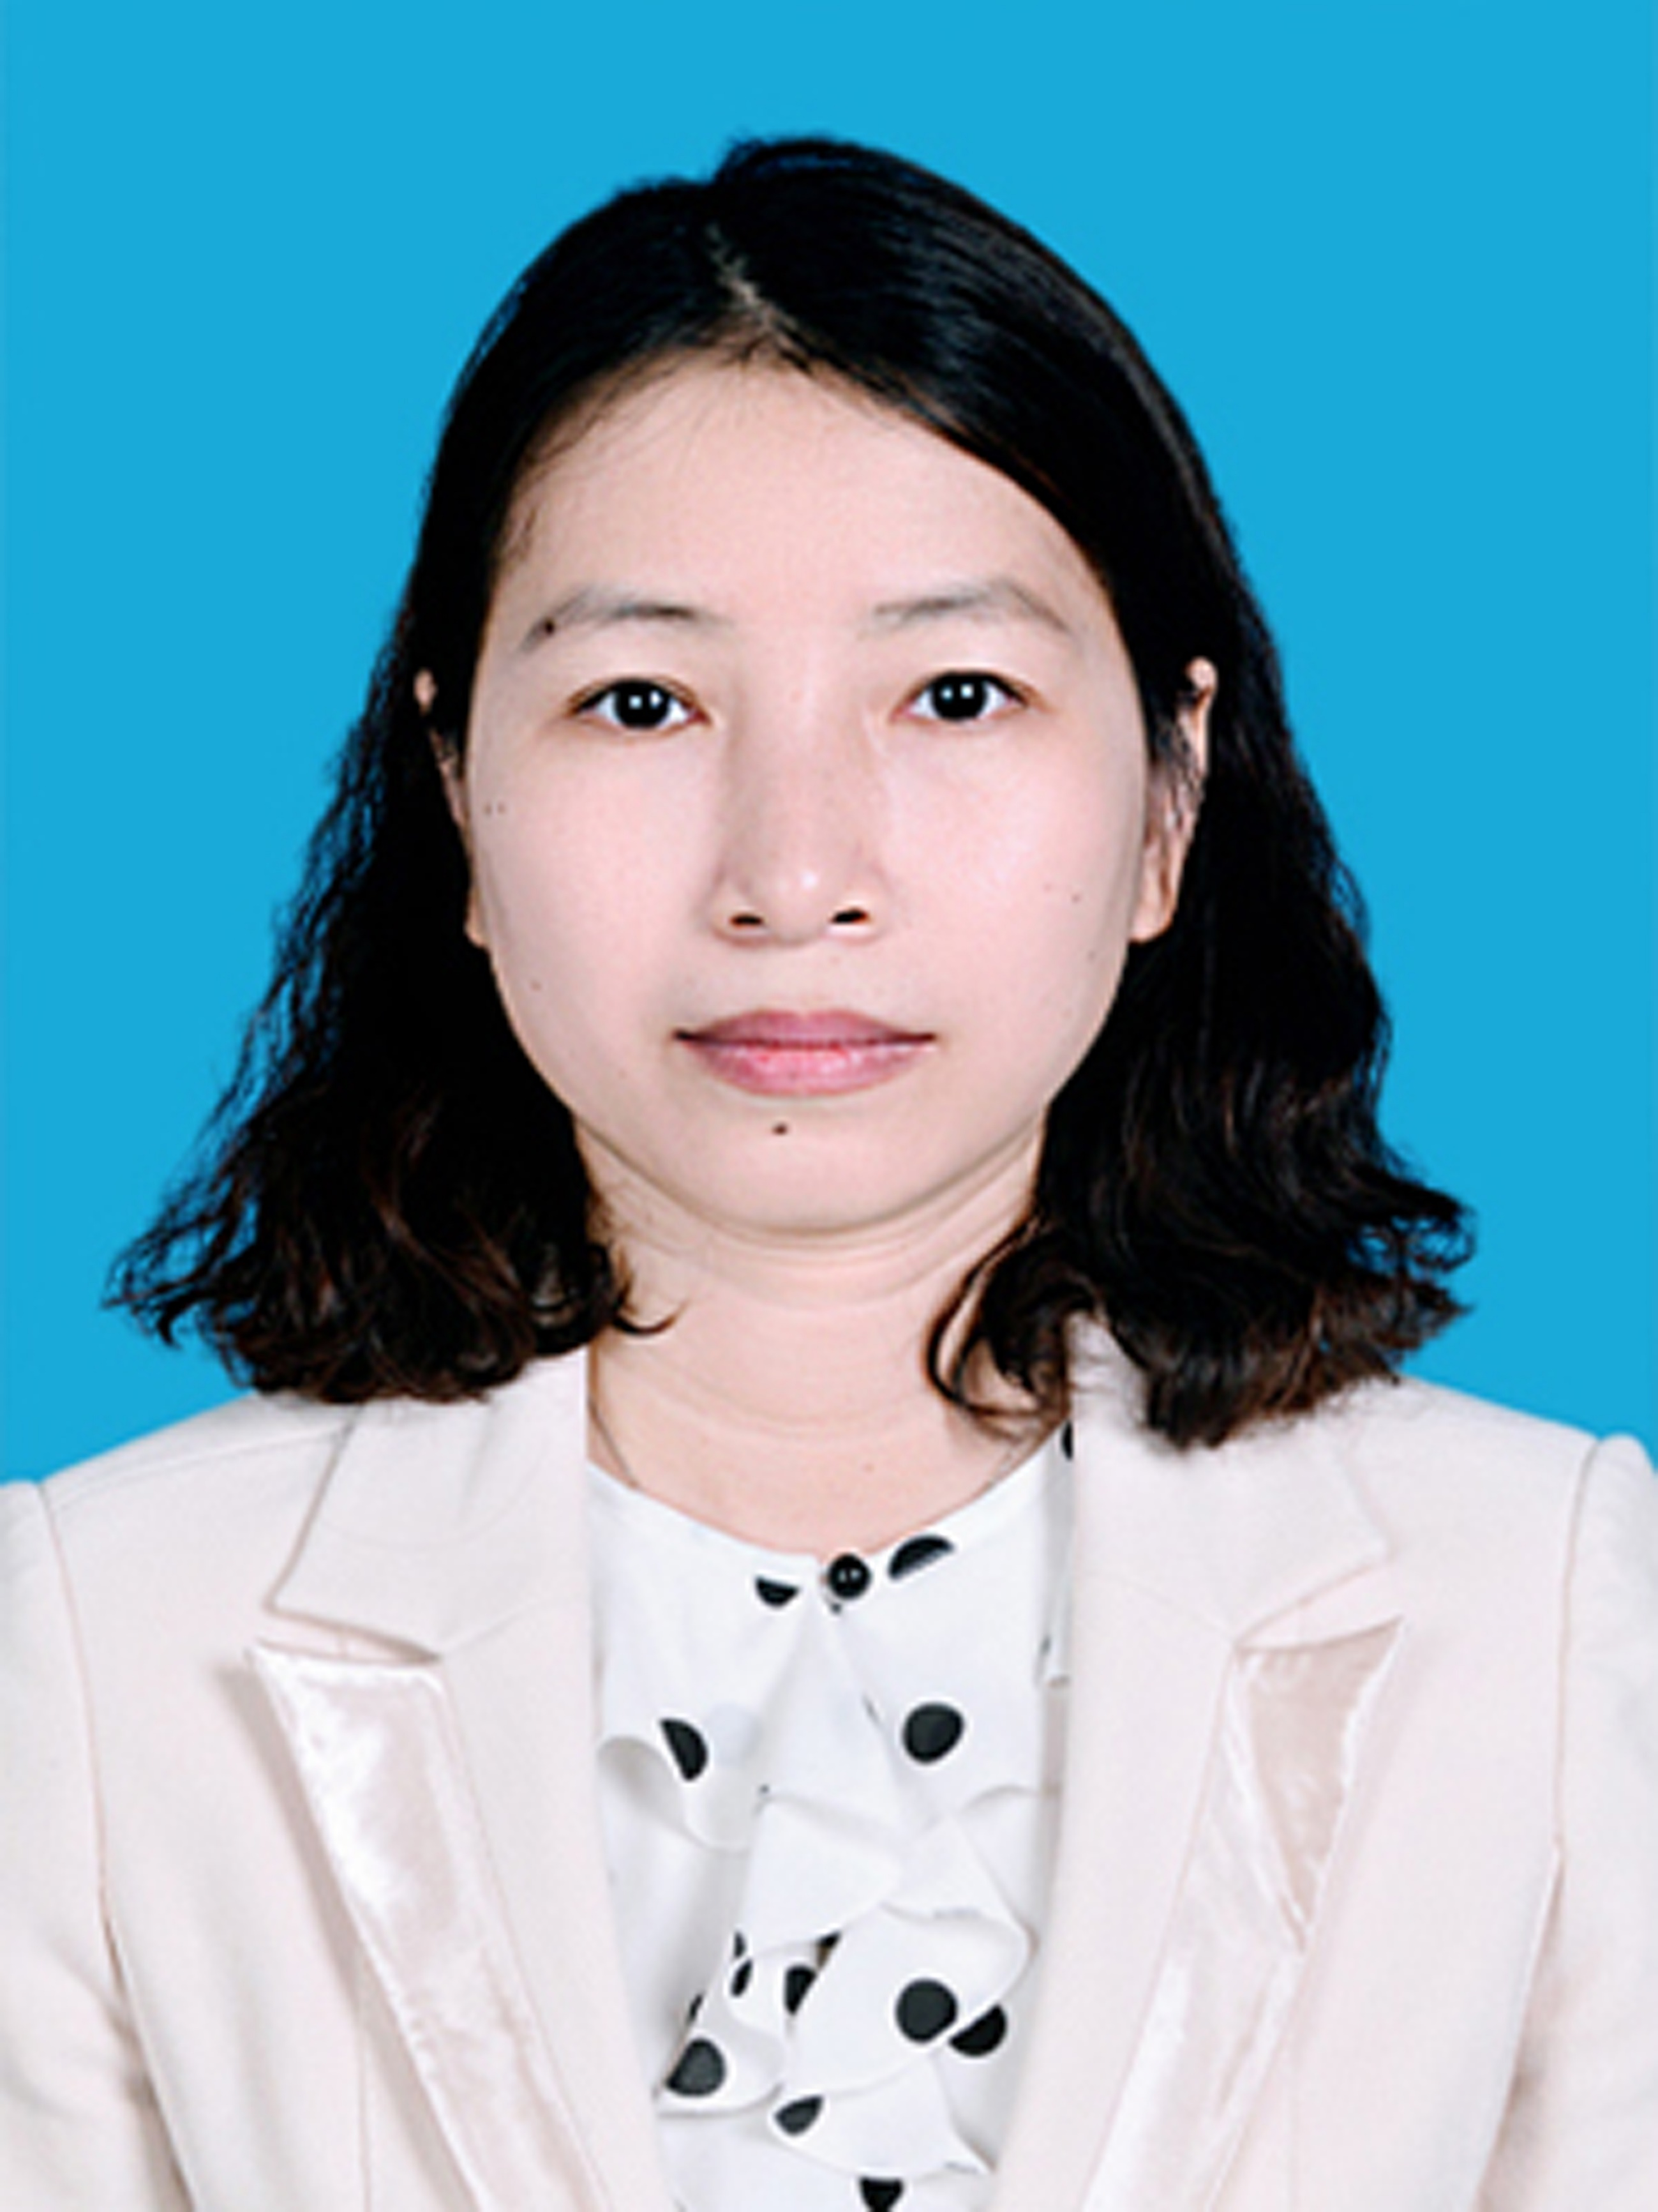

Department of Software Engineering
Faculty of Information Technology
Nha Trang University
02 Nguyen Dinh Chieu St., Nha Trang City, Vietnam

EDUCATION

School of Engineering and Technology, Asian Institute of Technology, Thailand
MSc. in Information Management, 2006.

VNUHCM-University of Science, Ho Chi Minh City, Vietnam
B.A. in Information System, 2001.

RESEARCH INTERESTS
- Software Engineering
- Web Technologies
- Data Science and Computational Statistics

RESEARCH EXPERIENCE
- Collaborator (system analyst) in the scientific research project at provincial level “To build a system of sharing information between
accommodation management organizations and businesses in Khanh Hoa province”, Vietnam, 2015-2017
- Member of the university research project ”Building an online system for training lecturers on using E-learning tools with Blended learning
model at Nha Trang University”, Vietnam, 2018-2019

TEACHING RESPONSIBILITY

Undergraduate:
- Software Engineering
- Applications Programming
- Introduction to programming
- Object Oriented Analysis and Design with UML
- Software Project Management

PUBLICATIONS and PRESENTATIONS
Books:
- Vo Van Tuan Dung, Le Thi Bich Hang, Pham Van Hai, Microsoft Access, Hong Duc Publisher, 2010, Publishing registration number: 187-2009/CXB/65-29/HĐ
- Le Thi Bich Hang, Object Oriented Analysis and Design with UML, Reference book in Nha Trang University, 2017
- Le Thi Bich Hang, Introduction to Programming, Reference book in Nha Trang University, 2020
Presentations:
- Le Thi Bich Hang, Applying Topic Maps to construct a system of managing and searching information, The 1st Conference on Information and Communications Technology, Vietnam, December 2015
- Nguyen Thuy Đoan Trang, Le Thi Bich Hang, Tran Minh Van, Mai Cuong Tho, Solutions on the way of coherent training between schools and businesses (Blended learning model), Conference on Association between universities and enterprises in training high quality human resources, Vietnam, 2019

